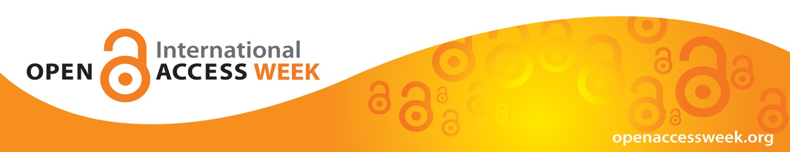

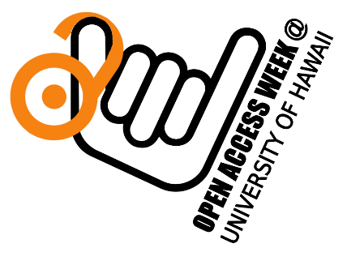
10th International Open Access Week
October 23-29
“Open in order to…”.

What is Open Access? How does it affect your access to affordable information resources, your research, and future publications?

Come learn!

- Monday, Oct 23, 2:00pm-Hamilton Library Sunny Alcove Keynote: “Why Open Access Matters at a R1 Research University – IVCAA/VCR Michael Bruno *Cookies & coffee provided.*

- Tuesday, Oct 24, 10:00am, Kuykendall Hall-106- “IP and the First Amendment- Censoring speech via the Digital Millennium Copyright Act”, *Cookies & coffee provided.*

- Tuesday, Oct 24, 11:30am, Kuykendall Hall-106- “Open Tools for Research” *Cookies & coffee provided.*

- Thursday, Oct 26, 10:00am, Kuykendall Hall-106 “Introduction to Open Educational Resources” (OER)” *Coffee and Pizza provided*

Register for the events using the QR code below

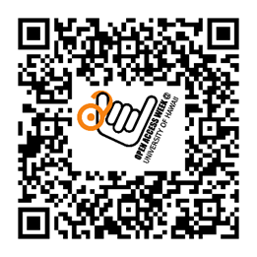

www.openaccessweek.org

